Measurements of Volatile Organic Compounds (VOCs) with PTR-MS
During SENEX 2013

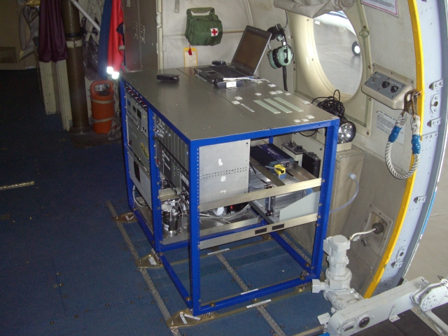
Principal Investigator: Martin Graus
NOAA ESRL Chemical Sciences Division
martin.graus@noaa.gov

Co-investigator: Carsten Warneke
NOAA ESRL Chemical Sciences Division
carsten.warneke@noaa.gov

Proton-transfer-reaction mass spectrometry (PTR-MS) [de Gouw et al., 2003; de Gouw and Warneke, 2007; Warneke et al., 2011] allows real-time measurements of volatile organic compounds (VOCs) in air with a high sensitivity and a fast time response. In PTR-MS, proton-transfer reactions with H₃O⁺ ions are used to ionize VOCs in air: H₃O⁺ + VOC → VOC.H⁺ + H₂O.

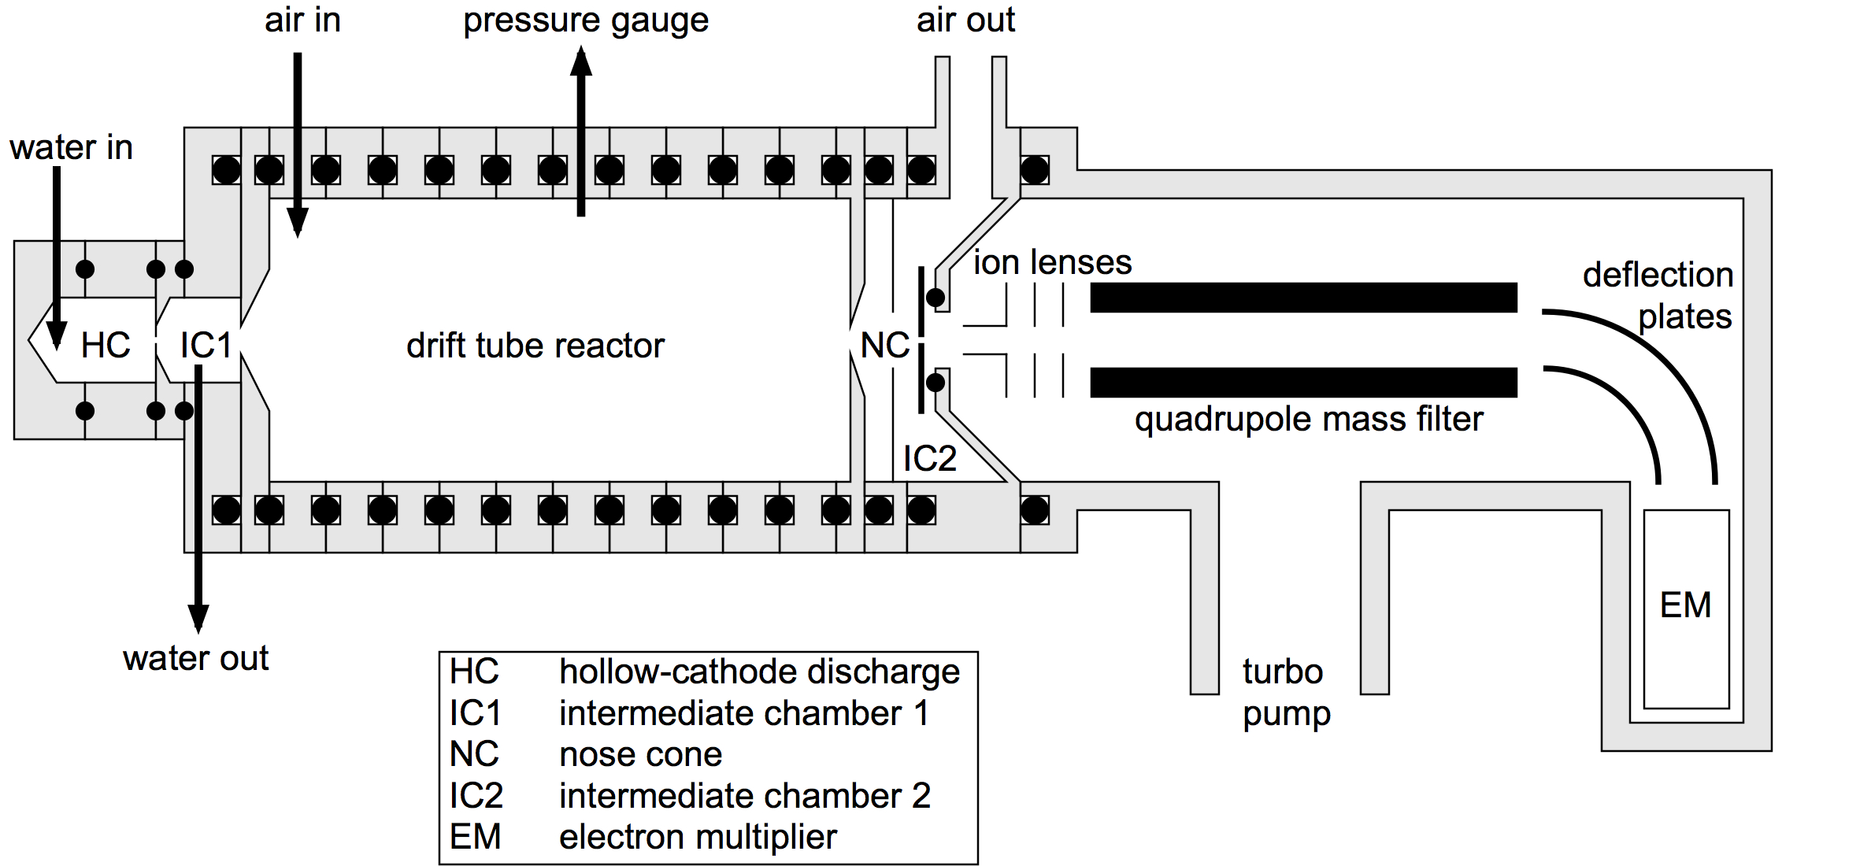
Figure 1: Schematic drawing of the PTR-MS instrument and the inlet.

The air to be analyzed is continuously pumped through a drift tube reactor, where the VOCs are ionized in the proton-transfer reactions with H₃O⁺, produced in the hollow-cathode discharge ion source. H₃O⁺ and product ions are detected with a quadrupole mass spectrometer. The inlet is pressure and temperature controlled and consists of PEEK and Teflon tubing and valves. The instrument is periodically zeroed by diverting the air through a catalytic converter that burns the VOCs. In between flights sensitivity calibrations are performed using dynamically diluted VOC standards.
VOCs with a higher proton affinity than water can be detected by PTR-MS and usually reported are: methanol, acetonitrile, acetaldehyde, acetone, isoprene, sum of methyl vinyl ketone and methacrolein, methyl ethyl ketone, benzene, toluene, sum of C8-aromatics, sum of C9-aromatics, and sum of monoterpenes.
The PTR-MS has a response time of about 1 second and all compounds are measured for 1 second every 17 seconds at detection limits of 30-200 pptv and an uncertainty of 20-30% dependent on the VOC.
The PTR-MS will be set-up for SENEX2013 nearly identical to what was used in many previous NOAA airborne field campaigns such as Calnex 2010 and ARCPAC 2008. The only difference is that the rack and inlet in Station 8 will be shared with another instrument.

References:
de Gouw, J., C. Warneke, T. Karl, G. Eerdekens, C. van der Veen, and R. Fall (2003), Sensitivity and specificity of atmospheric trace gas detection by proton-transfer-reaction mass spectrometry, International Journal of Mass Spectrometry, 223(1-3), 365-382, doi: doi:10.1016/S1387-3806(02)00926-0.
de Gouw, J. A., and C. Warneke (2007), Measurements of volatile organic compounds in the earths atmosphere using proton-transfer-reaction mass spectrometry, Mass Spectrometry Reviews, 26(2), 223-257.
Warneke, C., et al. (2011), Airborne formaldehyde measurements using PTR-MS: calibration, humidity dependence, inter-comparison and initial results, Atmospheric Measurement Techniques, 4(10), 2345-2358, doi: 10.5194/amt-4-2345-2011.

